Trinity Specialist College
Privacy Notice for Parents/Carers

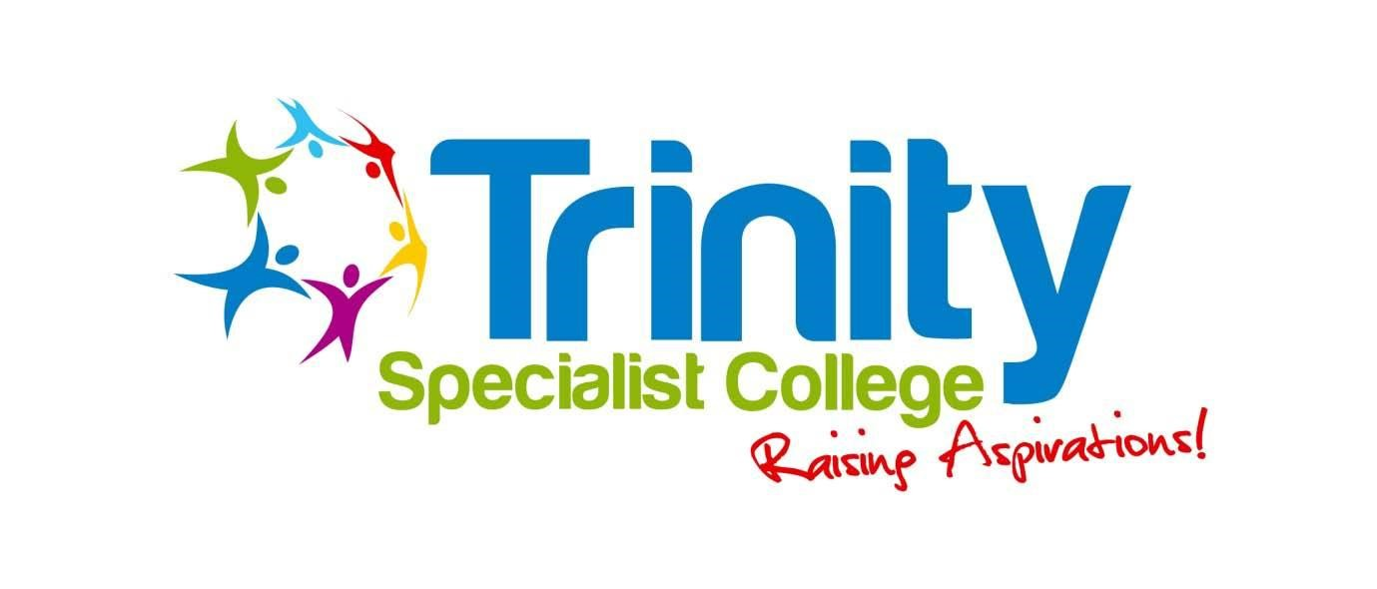
Policy reviewed | July 2020
Date for next review | July 2022
Signed by Chair of Trustees:

Privacy Notice for Parents/Carers

Under data protection law, individuals have a right to be informed about how the College uses any personal data that we hold about them. We comply with this right by providing ‘privacy notices’ (sometimes called ‘fair processing notices’) to individuals where we are processing their personal data.
This privacy notice explains how we collect, store and use personal data about learners/service users.
We, Trinity Specialist College, are the ‘data controller’ for the purposes of data protection law.
Our data protection officer is Peter Tsouvallaris, Trustee. .

The personal data we hold
Personal data that we may collect, use, store and share (when appropriate) about students/service users includes, but is not restricted to:
- Contact details, contact preferences, date of birth, identification documents
- Results of internal assessments and externally set tests
- Learner and curricular records
- Characteristics, such as ethnic background, eligibility for free College meals, or special educational needs
- Exclusion information
- Details of any medical conditions, including physical and mental health
- Attendance information
- Safeguarding information
- Details of any support received, including care packages, plans and support providers
- Photographs
- CCTV images captured in school
We may also hold data about students/service users that we have received from other organisations, including other schools, local authorities and the Department for Education.

Why we use this data
We use this data to:
- Support learner/service user learning
- Monitor and report on learner/service user progress
- Provide appropriate pastoral care
- Protect learner/service user welfare
- Assess the quality of our services
- Administer admissions waiting lists
- Carry out research
- Comply with the law regarding data sharing

Our legal basis for using this data
We only collect and use learners’/service users’ personal data when the law allows us to. Most commonly, we process it where:
- We need to comply with a legal obligation
- We need it to perform an official task in the public interest
Less commonly, we may also process students/service users’ personal data in situations where:
- We have obtained consent to use it in a certain way
- We need to protect the individual’s vital interests (or someone else’s interests)
Where we have obtained consent to use learners’/service users’ personal data, this consent can be withdrawn at any time. We will make this clear when we ask for consent and explain how consent can be withdrawn.
Some of the reasons listed above for collecting and using learners’/service users’ personal data overlap, and there may be several grounds, which justify our use of this data.

Collecting this information
While the majority of information we collect about leaners/service users is mandatory, there is some information that can be provided voluntarily.
Whenever we seek to collect information from you or your young person, we make it clear whether providing it is mandatory or optional. If it is mandatory, we will explain the possible consequences of not complying.
How we store this data
We keep personal information about learners/service users while they are attending our College. We may also keep it beyond their attendance at our school if this is necessary in order to comply with our legal obligations. Our Document Retention Schedule sets out how long we keep information about students/service users.
You can view and download a copy of the Document Retention Policy from our website at trinityspecialistcollege.co.uk

Data sharing
We do not share information about learners/service users with any third party without consent unless the law and our policies allow us to do so.
Where it is legally required or necessary (and it complies with data protection law), we may share personal information about learners/service users with:
- Our local authority – to meet our legal obligations to share certain information with it, such as safeguarding concerns and exclusions
- The Department for Education
- The ESFA (Education Skills Funding Agency)
- The learner/service user’s family and representatives
- Educators and examining bodies
- Our regulator Ofsted
- Suppliers and service providers – to enable them to provide the service we have contracted them for
- Professional bodies

Parents and students/service users’ rights regarding personal data
Individuals have a right to make a ‘subject access request’ to gain access to personal information that the college holds about them.
Parents/carers can make a request with respect to their young adult’s data where the young adult is not considered to have mental capacity to understand their rights over their own data, or where the young adult has provided consent.
Parents/carers also have the right to make a subject access request with respect to any personal data the school holds about them.
If you make a subject access request, and if we do hold information about you or your young adult, we will:
- Give you a description of it
- Tell you why we are holding and processing it, and how long we will keep it for
- Explain where we got it from, if not from you or your young adult
- Tell you who it has been, or will be, shared with
- Let you know whether any automated decision-making is being applied to the data, and any consequences of this
- Give you a copy of the information in an intelligible form
Individuals also have the right for their personal information to be transmitted electronically to another organisation in certain circumstances.
If you would like to make a request, please contact our data protection officer.

Other rights
Under data protection law, individuals have certain rights regarding how their personal data is used and kept safe, including the right to:
- Object to the use of personal data if it would cause, or is causing, damage or distress
- Prevent it being used to send direct marketing
- Object to decisions being taken by automated means (by a computer or machine, rather than by a person)
- In certain circumstances, have inaccurate personal data corrected, deleted or destroyed, or restrict processing
- Claim compensation for damages caused by a breach of the data protection regulations
To exercise any of these rights, please contact our data protection officer.

Complaints
We take any complaints about our collection and use of personal information very seriously.
If you think that our collection or use of personal information is unfair, misleading or inappropriate, or have any other concern about our data processing, please raise this with us in the first instance.
To make a complaint, please contact our data protection officer.
Alternatively, you can make a complaint to the Information Commissioner’s Office:
- Report a concern online at https://ico.org.uk/concerns/
- Call 0303 123 1113
- Or write to: Information Commissioner’s Office, Wycliffe House, Water Lane, Wilmslow, Cheshire, SK9 5AF

Contact us
If you have any questions, concerns or would like more information about anything mentioned in this privacy notice, please contact our data protection officer:
- Peter Tsouvallaris, Trinity Specialist College, The Lindridge, Lindridge Road, Sutton Coldfield, West Midlands, B75 7JB. Tel: 0121 378 3242.

