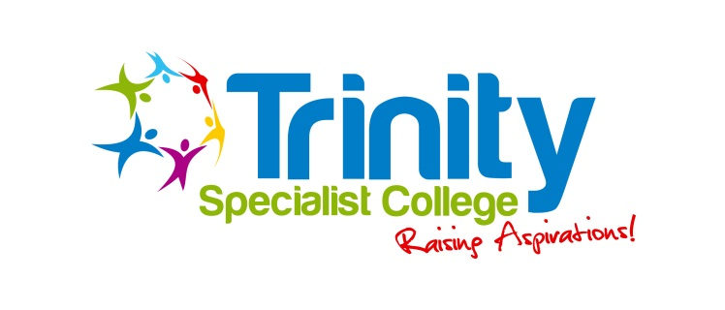

Complaints Procedure – Simplified Version
If you wish to make a complaint, please contact the College office in the first instance on 0121 378 3242.
They will take your details and get a member of the senior leadership team to return your call and discuss your complaint.
The following is the procedure for dealing with complaints:
Informal Stage – The College hope to be able to resolve most complaints at this stage.
- Discussions with Class Teacher/Principal by telephone, letter, or appointment.
- Serious concerns should be addressed to the Principal or to the CEO and Chair of the Trustee’s Board if the complaint is about the Principal.
Formal Stage - If your complaint is not resolved at the informal stage.
- You may choose to put your complaint in writing to the Principal or the CEO and Chair of Trustee’s if the complaint is about the Principal.
- The written complaint should include any details which may help with any investigation.
- Post or hand the complaint to the College office in a sealed envelope, addressed appropriately.
- You will be invited to a meeting to clarify your concerns.
- If not resolved at this stage an investigation will follow as soon as possible.
- The College will write to you with the outcome of the investigation.
- If you are satisfied with the outcome the process will end here.
- If you are not satisfied with the outcome you will have 10 days to ask the Trustee’s Board for a review of the process.
Review Process
Should a complaint get to this stage a panel of 3 Trustee’s would need to meet within 10 College days of the request being made.
You will be informed of the outcome.
The full Complaints Policy can be found on our website or a copy can be requested from the College office.

