Trinity Specialist College
Pandemic Policy

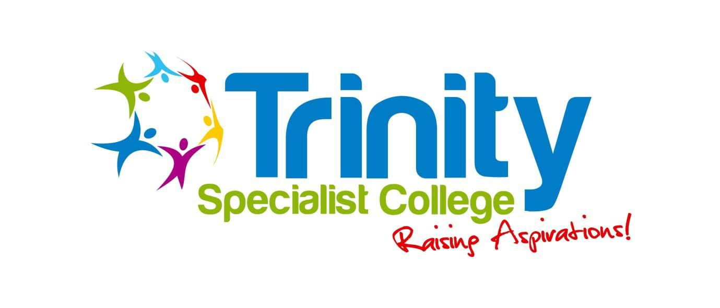

Policy reviewed | July 2020
Date for next review | July 2022
Signed by Chair of Trustees:

The policy of Trinity Specialist College is to remain open to healthy learners, unless directed otherwise by the Health Protection Agency. During a pandemic, we will attempt to provide as safe and educationally stimulating environment as possible.

We will also plan for the closure of the College to learners, which may be required by the local authority or the Department for Education.

Learners who are able to study from home but are unable to come to college because either they are ill or we have closed, will be able to
access a range of teaching materials and contact their teachers via video calls and email.

We would endeavour to support all members of our community in what might be a time of crisis.

It is difficult to predict when a pandemic will occur or how we will be affected by it. Each pandemic will react differently; some could spread throughout the country in a matter of weeks, in other cases it may take several months and in waves of differing duration. Therefore much of
the policy will need to be decided on a day to day basis. We will do as much as we can to prepare ourselves for an outbreak to enable us to
respond in an orderly fashion. The plan will need to be flexibly implemented to respond to the nature and severity of the outbreak.

Procedure

We will link our actions to the well-publicised WHO (World Health
Organisation) pandemic phases. Below are the actions that will be taken at each phase of its development.

WHO Phase 4
- Encourage parents to ensure contact information is up to date.
All staff, learners and parents/carers should call the college reception between 9am and 3pm on 0121 378 3242 to report any immediate concerns relating to an coronavirus infection. Outside of these hours confirmed cases of coronavirus should be reported to either the Principal on 07984 728314 or the Learner Support Administrator on 07538 862473
- In the event of the UK being an unaffected country all staff and
Parents/carers should call the college reception on 0121 378 3242

if they have travelled to an infected country. Once this information is known we will take the advice of UK Government and Public Health England concerning any quarantine which may be necessary.
The college will activate its pandemic risk assessment and update the college website with applicable information.

WHO Phase 5
All staff, learners and parents/carers should call the college reception between 9am and 3pm on 0121 378 3242 to report any immediate concerns relating to coronavirus infection. Outside of these hours confirmed cases of coronavirus should be reported to either the Principal on 07984 728314 or the Learner Support Administrator on 07538 862473
In the event of the UK being an unaffected country all staff and parents/carers should call the college reception if they have travelled to an infected country. Once this information is known we will take the advice of the UK Government and Public Health England concerning any quarantine which may be necessary.
All trips, visits, will be risk assessed specifically to deal with pandemic and quarantine issues.
The creation of work capable of being accessed remotely is produced.
phase 6.
The college website will contain further information.
WHO Phase 6
This phase occurs when there a pandemic is announced by WHO
The college will follow any plans issued by the government and/or authorities.
All staff, learners and parents/carers should call the college reception between 9am and 3pm on 0121 378 3242 to
report any immediate concerns relating to coronavirus infection.
Outside of these hours confirmed cases of coronavirus should be reported to either the Principal on 07984 728314 or the Learner Support Administrator on 07538 862473.
The senior management team will meet on a daily basis to consider that day’s operation, the implementation of the plan and the Government’s latest advice.
The college will publish plans to staff and parents regarding procedures during a pandemic while it remains open, e.g. isolation areas, meal provision, crisis management team contact details and any enforced hygiene protocols.

The college will issue its plan for closure should this be
necessary. This will include information on arrangements on
how to access study materials and how to contact staff.
In the event of college closure during the college day, parents/carers will be contacted to enable them to make arrangements for the collection of their young person. For those who we have been unable to contact, separate provision will be made for their learner to enable collection at the normal time. For closure at the end of a college day, parents/carers will be informed by telephone.
The college website will contain further information.

The plan for re-opening of the college will be communicated to parents/carers by telephone or letter.

For further information, please contact the college.

The following useful websites might help with any specific queries you have:

www.directgov.uk
www.nhsdirect.nhs.uk

